ASSIGNMENT-4
Subject – Computer Science Workshop-1(CSE 2141)
NAME – DEEPTESH ROUT
Registration Number – 2341018166
Section – 23412G1 Branch – B. Tech (CSE)

1. Design a responsive webpage using Bootstrap grids: Create a layout with four rows,
each styled with a solid border and a light green background.
i. First row: Divide into two equal columns for extra small screen sizes (<576px).
ii. Second row: Divide into three equal columns for extra small screen sizes (<576px).
iii. Third row: Divide into four equal columns for small screen sizes (≥576px).
iv. Fourth row: Divide into six equal columns for medium screen sizes (≥768px).

HTML CODE :-

<html>
<head>
<meta charset="UTF-8">
<meta name="viewport" content="width=device-width, initial-scale=1.0">
<title>Responsive Grid Layout</title>
<link rel="stylesheet" href="https://maxcdn.bootstrapcdn.com/bootstrap/4.2.1/css/bootstrap.min.css">

<script src="https://ajax.googleapis.com/ajax/libs/jquery/3.3.1/jquery.min.js"></script>
<script src="https://maxcdn.bootstrapcdn.com/bootstrap/4.2.1/js/bootstrap.min.js"></script>

<style>
.row-style {
border: 1px solid #000;
background-color: lightgreen;
margin-bottom: 10px;
}
.column-style {
border: 1px solid #000;
padding: 20px;
text-align: center;
}
</style>
</head>
<body>

<div class="container">
<h1 class="display-1">Bootstrap Grids</h1>
<h1>First Row with 2 equal Column</h1>
<div class="row row-style">
<div class="col-6 column-style">Column 1</div>
<div class="col-6 column-style">Column 2</div>
</div>

<h1>Second Row with 3 equal Column</h1>
<div class="row row-style">
<div class="col-4 column-style">Column 1</div>
<div class="col-4 column-style ">Column 2</div>
<div class="col-4 column-style">Column 3</div>
</div>
<h1>Thrid Row with 4 equal Column</h1>
<div class="row row-style">
<div class="col-sm-3 column-style ">Column 1</div>
<div class="col-sm-3 column-style">Column 2</div>
<div class="col-sm-3 column-style">Column 3</div>
<div class="col-sm-3 column-style">Column 4</div>
</div>
<h1>Forth Row with 6 equal Column</h1>
<div class="row row-style">
<div class="col-md-2 column-style ">Column 1</div>
<div class="col-md-2 column-style">Column 2</div>
<div class="col-md-2 column-style">Column 3</div>
<div class="col-md-2 column-style">Column 4</div>
<div class="col-md-2 column-style">Column 5</div>
<div class="col-md-2 column-style">Column 6</div>
</div>
</div>
</body>
</html>

OUTPUT OF THE CODE
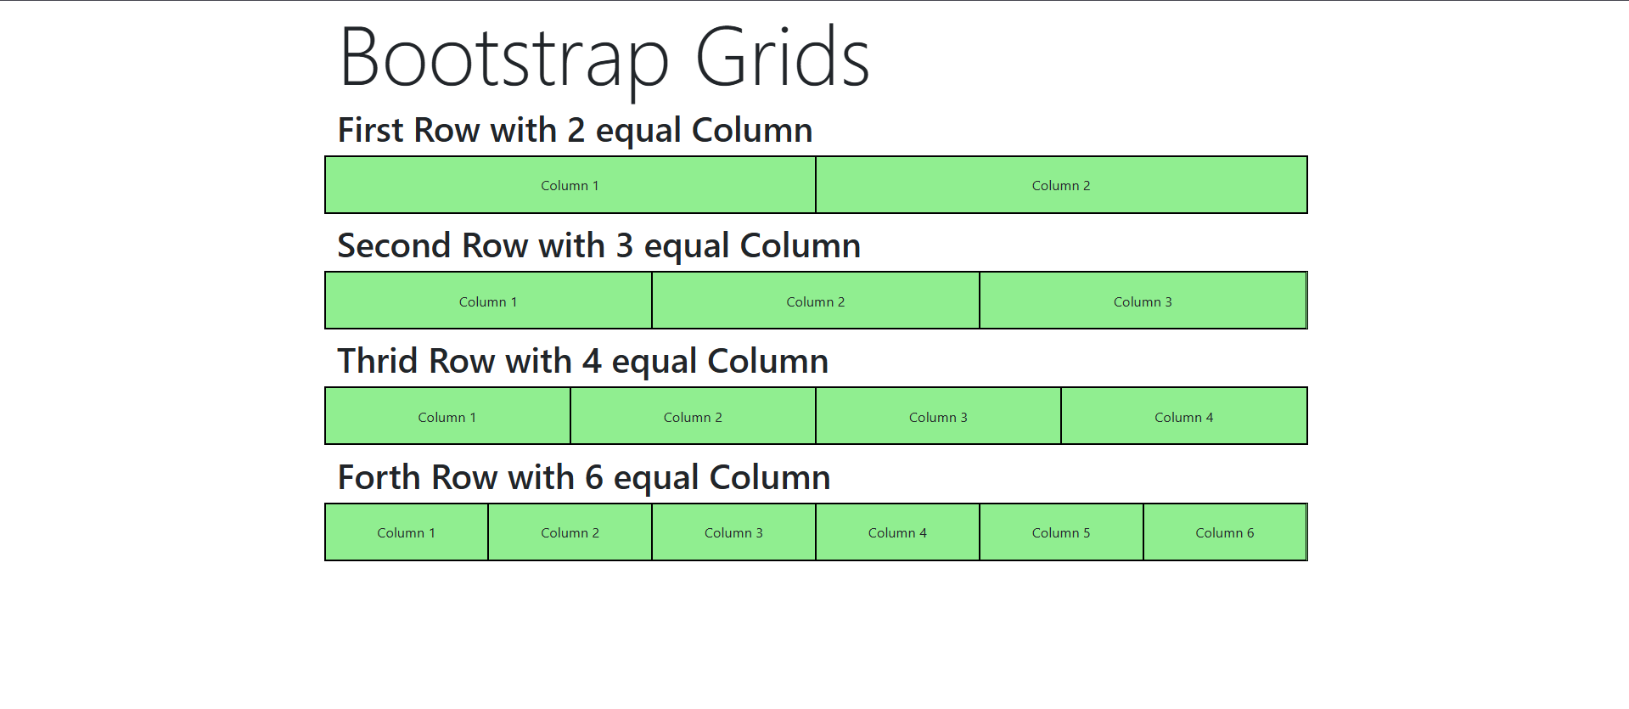

2. Apply different Bootstrap background colors (e.g., bg-primary, bg-success, etc.) and text colors (e.g., text-white, text-dark, etc.) to each column created in Q1.

HTML CODE:-

<html>
<head>
<meta charset="UTF-8">
<meta name="viewport" content="width=device-width, initial-scale=1.0">
<title>Deeptesh Rout</title>
<link rel="stylesheet" href="https://maxcdn.bootstrapcdn.com/bootstrap/4.2.1/css/bootstrap.min.css">

<script src="https://ajax.googleapis.com/ajax/libs/jquery/3.3.1/jquery.min.js"></script>
<script src="https://maxcdn.bootstrapcdn.com/bootstrap/4.2.1/js/bootstrap.min.js"></script>

<style>
.row-style {
border: 1px solid #000;
background-color: lightgreen;
margin-bottom: 10px;
}
.column-style {
border: 1px solid #000;
padding: 20px;
text-align: center;
}
</style>
</head>
<body>

<div class="container">
<h1 class="display-1">Bootstrap Gridss</h1>
<h1>First Row with 2 equal Column</h1>
<div class="row row-style">
<div class="col-6 column-style bg-info text-white">Column 1</div>
<div class="col-6 column-style">Column 2</div>
</div>

<h1>Second Row with 3 equal Column</h1>
<div class="row row-style">
<div class="col-4 column-style bg-warning">Column 1</div>
<div class="col-4 column-style bg-light ">Column 2</div>
<div class="col-4 column-style bg-success text-black">Column 3</div>
</div>
<h1>Thrid Row with 4 equal Column</h1>
<div class="row row-style">
<div class="col-sm-3 column-style bg-danger text-primary">Column 1</div>
<div class="col-sm-3 column-style ">Column 2</div>
<div class="col-sm-3 column-style bg-secondary text-warning">Column 3</div>
<div class="col-sm-3 column-style bg-dark text-white">Column 4</div>
</div>
<h1>Forth Row with 6 equal Column</h1>
<div class="row row-style">
<div class="col-md-2 column-style bg-dark text-white">Column 1</div>
<div class="col-md-2 column-style bg-dark text-primary">Column 2</div>
<div class="col-md-2 column-style bg-dark text-white">Column 3</div>
<div class="col-md-2 column-style bg-dark text-primary">Column 4</div>
<div class="col-md-2 column-style bg-dark text-white">Column 5</div>
<div class="col-md-2 column-style bg-dark text-primary">Column 6</div>
</div>
</div>
</body>
</html>

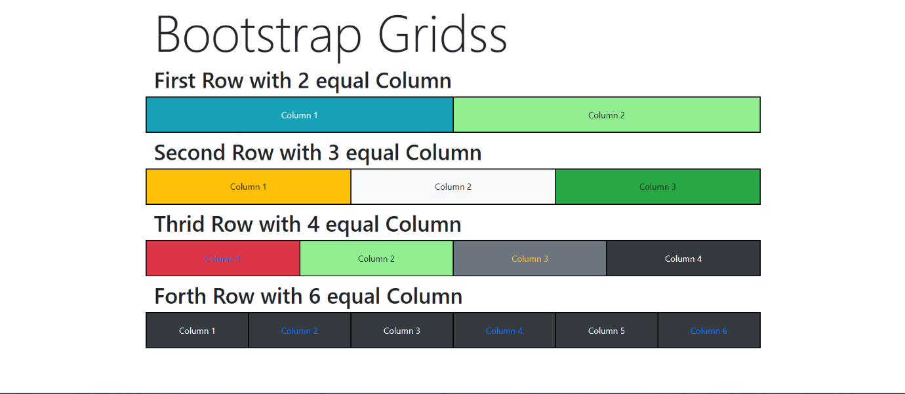
OUTPUT OF THE CODE :-

3. Create a grid with three equal-sized columns, each containing an image styled as a thumbnail and set to a size of 200x200 pixels. Add a button that, when clicked, changes the thumbnail image style to a circular image.

HTML CODE

<!DOCTYPE html>
<html lang="en">
<head>
<meta charset="UTF-8">
<meta name="viewport" content="width=device-width, initial-scale=1.0">
<title>Thumbnail to Circular Image</title>
<link rel="stylesheet" href="styles.css">
<style>
body {
font-family: Arial, sans-serif;
display: flex;
justify-content: center;
align-items: center;
height: 100vh;
margin: 0;
}

.container {
text-align: center;
}

.image-grid {
display: grid;
grid-template-columns: repeat(3, 200px);
gap: 20px;
margin-bottom: 20px;
}

.image-item img {
width: 200px;
height: 200px;
object-fit: cover;
transition: border-radius 0.3s ease;
}

.thumbnail {
border-radius: 0%;
}

.toggle-input {
display: none;
}

.toggle-button {
padding: 10px 20px;
background-color: #4CAF50;
color: white;
border: none;
cursor: pointer;
font-size: 16px;
display: inline-block;
margin-bottom: 20px;
}

.toggle-button:hover {
background-color: #45a049;
}

.toggle-input:checked ~ .image-grid .image-item img {
border-radius: 50%;
}
</style>
</head>
<body>

<div class="container">
<!-- Checkbox that triggers the style change -->
<input type="checkbox" id="toggle" class="toggle-input">
<label for="toggle" class="toggle-button">Change to Circular</label>

<div class="image-grid">
<div class="image-item">
<img src="https://encrypted-tbn0.gstatic.com/images?q=tbn:ANd9GcSxljCiU3pRUXpw-39aklTNk7BDV3G9Dn7ocw&s" alt="Image 1" class="thumbnail">
</div>
<div class="image-item">
<img src="https://th.bing.com/th/id/OIG3.80EN2JPNx7kp5VqoB5kz" alt="Image 2" class="thumbnail">
</div>
<div class="image-item">
<img src="https://encrypted-tbn0.gstatic.com/images?q=tbn:ANd9GcThn2O4f85iRUGth0pwLOtyRf-g24gOMKcPbQ&s" alt="Image 3" class="thumbnail">
</div>
</div>
</div>

</body>
</html>

OUTPUT 1 OUTPUT 2

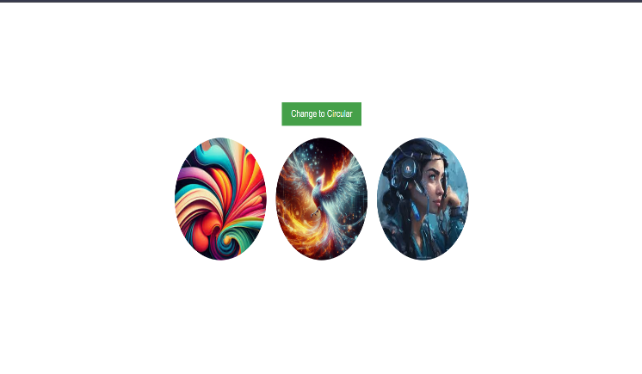
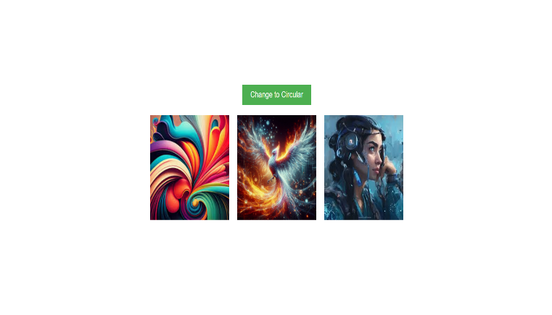

4.Create six different types of alert boxes, each with an appropriate link, a closing button, and a suitable emphasized message. Add animated effects to each alert box with a 5 second transition effect.

HTML CODE

<!DOCTYPE html>
<html lang="en">
<head>
<title>Animated Alerts with jQuery</title>
<meta charset="utf-8">
<meta name="viewport" content="width=device-width, initial-scale=1">
<link rel="stylesheet" href="https://maxcdn.bootstrapcdn.com/bootstrap/4.1.3/css/bootstrap.min.css">
<script src="https://ajax.googleapis.com/ajax/libs/jquery/3.3.1/jquery.min.js"></script>
<script src="https://cdnjs.cloudflare.com/ajax/libs/popper.js/1.14.3/umd/popper.min.js"></script>
<script src="https://maxcdn.bootstrapcdn.com/bootstrap/4.1.3/js/bootstrap.min.js"></script>

<style>
.alert {
display: none;
}
</style>

</head>
<body>

<div class="container mt-4">
<h1>Animated Alert Example</h1>

<!-- Success Alert -->
<div class="alert alert-success alert-dismissible" role="alert">
<button type="button" class="close" data-dismiss="alert">&times;</button>
<strong>Congratulations!</strong> Your ID was successfully created!
</div>

<!-- Info Alert -->
<div class="alert alert-info alert-dismissible" role="alert">
<button type="button" class="close" data-dismiss="alert">&times;</button>
<strong>Information!</strong> Check our About Us page to see our services.
</div>

<!-- Warning Alert -->
<div class="alert alert-warning alert-dismissible" role="alert">
<button type="button" class="close" data-dismiss="alert">&times;</button>
<strong>Warning!</strong> Avoid travel in this weather.
</div>

<!-- Danger Alert -->
<div class="alert alert-danger alert-dismissible" role="alert">
<button type="button" class="close" data-dismiss="alert">&times;</button>
<strong>Danger!</strong> This website may contain a virus.
</div>

<!-- Primary Alert -->
<div class="alert alert-primary alert-dismissible" role="alert">
<button type="button" class="close" data-dismiss="alert">&times;</button>
<strong>Attention!</strong> The flight to Detroit is cancelled!
</div>

<!-- Secondary Alert -->
<div class="alert alert-secondary alert-dismissible" role="alert">
<button type="button" class="close" data-dismiss="alert">&times;</button>
<strong>Suggestion:</strong> Use a text editor for professional web designing projects.
</div>

<!-- Dark Alert -->
<div class="alert alert-dark alert-dismissible" role="alert">
<button type="button" class="close" data-dismiss="alert">&times;</button>
<strong>See Below</strong> to understand the random forest algorithm.
</div>

<!-- Light Alert -->
<div class="alert alert-light alert-dismissible" role="alert">
<button type="button" class="close" data-dismiss="alert">&times;</button>
<strong>See above!</strong> to understand the decision tree algorithm.
</div>

</div>

<script>
$(document).ready(function() {
// Apply a 5-second fade-in animation with delay for each alert box
$(".alert").each(function(index) {
$(this).delay(index * 5000).fadeIn(5000); // Delay 5 seconds for each alert box before showing
});

// Dismiss alert on close button click
$('.close').click(function() {
$(this).closest('.alert').fadeOut(2000); // Fade out alert when clicked
});
});
</script>

</body>
</html>

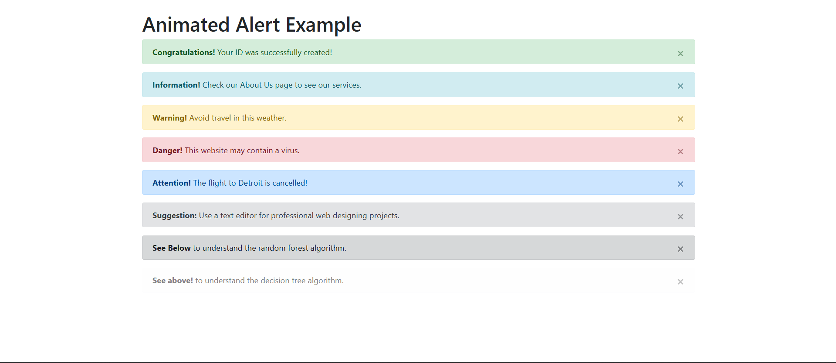

5. Create a nested dropdown menu with multiple levels. The button group should have four primary categories, such as 'Category 1', 'Category 2', etc., with each category containing four subcategories, such as 'Subcategory 1', 'Subcategory 2', etc. Implement the structure using <div> elements with the class btn group for the categories. Include dropdowns for each subcategory using the class dropdown-toggle and dropdown-menu. The dropdown items should be links (<a>) with the class dropdown-item for each option.

HTML CODE

<!DOCTYPE html>
<html lang="en">
<head>
<meta charset="UTF-8">
<meta name="viewport" content="width=device-width, initial-scale=1.0">
<title>Nested Dropdown Menu</title>

<!-- Bootstrap CSS -->
<link rel="stylesheet" href="https://maxcdn.bootstrapcdn.com/bootstrap/4.5.2/css/bootstrap.min.css">

<!-- jQuery and Bootstrap JS -->
<script src="https://ajax.googleapis.com/ajax/libs/jquery/3.5.1/jquery.min.js"></script>
<script src="https://cdnjs.cloudflare.com/ajax/libs/popper.js/1.16.0/umd/popper.min.js"></script>
<script src="https://maxcdn.bootstrapcdn.com/bootstrap/4.5.2/js/bootstrap.min.js"></script>

<style>
/* Custom CSS for handling the position of nested dropdown */
.dropdown-submenu {
position: relative;
}

.dropdown-submenu>.dropdown-menu {
top: 0;
left: 100%;
margin-top: -5px;
margin-left: 1px;
border-radius: 0.25rem;
}

/* Ensure that the dropdown menus stay visible when hovering */
.dropdown:hover .dropdown-menu {
display: block;
}

.dropdown-submenu:hover>.dropdown-menu {
display: block;
}
</style>
</head>
<body>

<div class="container mt-4">
<h2>Nested Dropdown Menu Example</h2>

<!-- Button Group for Categories -->
<div class="btn-group">
<button type="button" class="btn btn-primary dropdown-toggle" data-toggle="dropdown" aria-haspopup="true" aria-expanded="false">
Category 1
</button>
<div class="dropdown-menu">
<a class="dropdown-item" href="#">Subcategory 1</a>
<a class="dropdown-item" href="#">Subcategory 2</a>
<a class="dropdown-item" href="#">Subcategory 3</a>
<a class="dropdown-item" href="#">Subcategory 4</a>
<!-- Nested Subcategory Dropdown -->
<div class="dropdown-submenu">
<a class="dropdown-item dropdown-toggle" href="#">Subcategory 5</a>
<div class="dropdown-menu">
<a class="dropdown-item" href="#">Option 1</a>
<a class="dropdown-item" href="#">Option 2</a>
<a class="dropdown-item" href="#">Option 3</a>
</div>
</div>
</div>
</div>

<div class="btn-group ml-2">
<button type="button" class="btn btn-primary dropdown-toggle" data-toggle="dropdown" aria-haspopup="true" aria-expanded="false">
Category 2
</button>
<div class="dropdown-menu">
<a class="dropdown-item" href="#">Subcategory 1</a>
<a class="dropdown-item" href="#">Subcategory 2</a>
<a class="dropdown-item" href="#">Subcategory 3</a>
<a class="dropdown-item" href="#">Subcategory 4</a>
<!-- Nested Subcategory Dropdown -->
<div class="dropdown-submenu">
<a class="dropdown-item dropdown-toggle" href="#">Subcategory 5</a>
<div class="dropdown-menu">
<a class="dropdown-item" href="#">Option 1</a>
<a class="dropdown-item" href="#">Option 2</a>
<a class="dropdown-item" href="#">Option 3</a>
</div>
</div>
</div>
</div>

<div class="btn-group ml-2">
<button type="button" class="btn btn-primary dropdown-toggle" data-toggle="dropdown" aria-haspopup="true" aria-expanded="false">
Category 3
</button>
<div class="dropdown-menu">
<a class="dropdown-item" href="#">Subcategory 1</a>
<a class="dropdown-item" href="#">Subcategory 2</a>
<a class="dropdown-item" href="#">Subcategory 3</a>
<a class="dropdown-item" href="#">Subcategory 4</a>
<!-- Nested Subcategory Dropdown -->
<div class="dropdown-submenu">
<a class="dropdown-item dropdown-toggle" href="#">Subcategory 5</a>
<div class="dropdown-menu">
<a class="dropdown-item" href="#">Option 1</a>
<a class="dropdown-item" href="#">Option 2</a>
<a class="dropdown-item" href="#">Option 3</a>
</div>
</div>
</div>
</div>

<div class="btn-group ml-2">
<button type="button" class="btn btn-primary dropdown-toggle" data-toggle="dropdown" aria-haspopup="true" aria-expanded="false">
Category 4
</button>
<div class="dropdown-menu">
<a class="dropdown-item" href="#">Subcategory 1</a>
<a class="dropdown-item" href="#">Subcategory 2</a>
<a class="dropdown-item" href="#">Subcategory 3</a>
<a class="dropdown-item" href="#">Subcategory 4</a>
<!-- Nested Subcategory Dropdown -->
<div class="dropdown-submenu">
<a class="dropdown-item dropdown-toggle" href="#">Subcategory 5</a>
<div class="dropdown-menu">
<a class="dropdown-item" href="#">Option 1</a>
<a class="dropdown-item" href="#">Option 2</a>
<a class="dropdown-item" href="#">Option 3</a>
</div>
</div>
</div>
</div>
</div>
</body>
</html>

OUTPUT

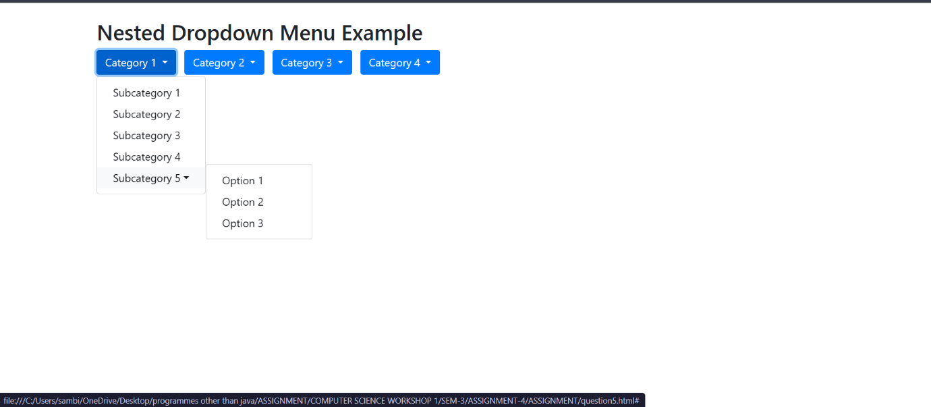

6. Create a webpage with four animated progress bars using Bootstrap, applying the progress-bar-striped and progress-bar-animated classes, each with a different background color. The progress bars should initially be hidden and only appear when the user clicks the 'Upload File' button. Implement a function that gradually increases the width of each progress bar from 0% to 100%, with a 1% increment every 100 milliseconds. Use jQuery to control the display and animation of the progress bars, ensuring they fill sequentially.

HTML CODE :-

<!DOCTYPE html>
<html lang="en">
<head>
<meta charset="UTF-8">
<meta name="viewport" content="width=device-width, initial-scale=1.0">
<title>Progress Bar Animation</title>
<!-- Bootstrap CSS -->
<link href="https://stackpath.bootstrapcdn.com/bootstrap/4.5.2/css/bootstrap.min.css" rel="stylesheet">
<style>
.progress-container {
display: none;
}
</style>
</head>
<body>

<div class="container mt-5">
<h3 class="text-center">Progress Bar Animation Example</h3>

<!-- Button to trigger progress bars animation -->
<div class="text-center mt-4">
<button id="uploadButton" class="btn btn-primary">Upload File</button>
</div>

<!-- Container for the progress bars (initially hidden) -->
<div id="progressContainer" class="progress-container mt-4">
<!-- Progress Bar 1 -->
<div class="progress mb-2">
<div id="progressBar1" class="progress-bar progress-bar-striped progress-bar-animated" style="width: 0%; background-color: #007bff;" role="progressbar" aria-valuenow="0" aria-valuemin="0" aria-valuemax="100"></div>
</div>

<!-- Progress Bar 2 -->
<div class="progress mb-2">
<div id="progressBar2" class="progress-bar progress-bar-striped progress-bar-animated" style="width: 0%; background-color: #28a745;" role="progressbar" aria-valuenow="0" aria-valuemin="0" aria-valuemax="100"></div>
</div>

<!-- Progress Bar 3 -->
<div class="progress mb-2">
<div id="progressBar3" class="progress-bar progress-bar-striped progress-bar-animated" style="width: 0%; background-color: #ffc107;" role="progressbar" aria-valuenow="0" aria-valuemin="0" aria-valuemax="100"></div>
</div>

<!-- Progress Bar 4 -->
<div class="progress mb-2">
<div id="progressBar4" class="progress-bar progress-bar-striped progress-bar-animated" style="width: 0%; background-color: #dc3545;" role="progressbar" aria-valuenow="0" aria-valuemin="0" aria-valuemax="100"></div>
</div>
</div>
</div>

<!-- jQuery and Bootstrap JS -->
<script src="https://code.jquery.com/jquery-3.5.1.min.js"></script>
<script src="https://cdn.jsdelivr.net/npm/@popperjs/core@2.5.4/dist/umd/popper.min.js"></script>
<script src="https://stackpath.bootstrapcdn.com/bootstrap/4.5.2/js/bootstrap.min.js"></script>

<script>
$(document).ready(function() {
// Button click event
$('#uploadButton').click(function() {
$('#progressContainer').fadeIn(); // Show the progress container
animateProgressBars(); // Start the animation
});

function animateProgressBars() {
let progressBar1 = $('#progressBar1');
let progressBar2 = $('#progressBar2');
let progressBar3 = $('#progressBar3');
let progressBar4 = $('#progressBar4');

animateSingleProgressBar(progressBar1, 0, function() {
animateSingleProgressBar(progressBar2, 0, function() {
animateSingleProgressBar(progressBar3, 0, function() {
animateSingleProgressBar(progressBar4, 0);
});
});
});
}

function animateSingleProgressBar(progressBar, progress, callback) {
let interval = setInterval(function() {
if (progress < 100) {
progress++;
progressBar.css('width', progress + '%').attr('aria-valuenow', progress);
} else {
clearInterval(interval); // Stop the current interval when 100% is reached
if (callback) callback(); // Call the callback to start the next progress bar
}
}, 100);
}
});
</script>

</body>
</html>

OUTPUT

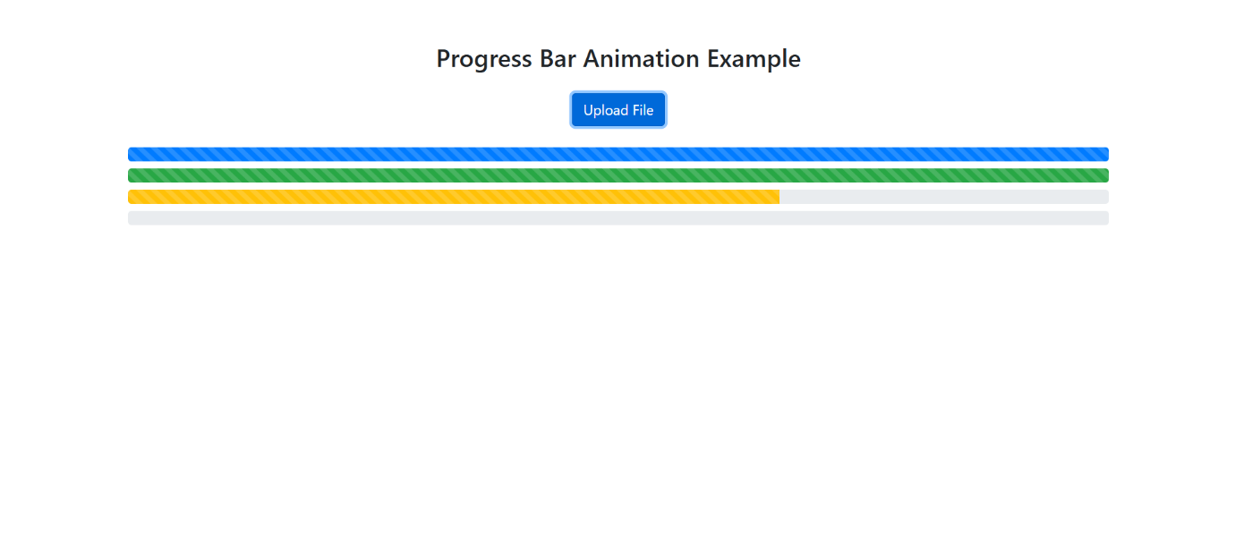

7. Create four HTML pages, each containing a Bootstrap header with a color class of your choice and centered alignment. Add pagination to each page, linking them to the corresponding HTML pages. Use the proper attribute to open the page in a new blank tab. Ensure that the active class changes to reflect the current page.

HTML CODE :-

PAGE 1 HTML CODE

<!DOCTYPE html>
<html lang="en">
<head>
<meta charset="UTF-8">
<meta name="viewport" content="width=device-width, initial-scale=1.0">
<title>Page 1</title>
<!-- Bootstrap CSS -->
<link href="https://stackpath.bootstrapcdn.com/bootstrap/4.5.2/css/bootstrap.min.css" rel="stylesheet">
</head>
<body>
<div class="container mt-4">
<!-- Header with centered alignment and color class -->
<div class="text-center bg-primary text-white p-3">
<h1>Page 1</h1>
</div>

<!-- Page content -->
<div class="text-center mt-4">
<p>Welcome to Page 1. Use the pagination links below to navigate.</p>
</div>

<!-- Pagination -->
<div class="d-flex justify-content-center">
<ul class="pagination">
<li class="page-item">
<a class="page-link" href="page4.html" target="_blank">Previous</a>
</li>
<li class="page-item active">
<a class="page-link" href="page1.html" target="_blank">1</a>
</li>
<li class="page-item">
<a class="page-link" href="page2.html" target="_blank">2</a>
</li>
<li class="page-item">
<a class="page-link" href="page3.html" target="_blank">3</a>
</li>
<li class="page-item">
<a class="page-link" href="page2.html" target="_blank">Next</a>
</li>
</ul>
</div>
</div>

<!-- Bootstrap JS -->
<script src="https://code.jquery.com/jquery-3.5.1.min.js"></script>
<script src="https://cdn.jsdelivr.net/npm/@popperjs/core@2.5.4/dist/umd/popper.min.js"></script>
<script src="https://stackpath.bootstrapcdn.com/bootstrap/4.5.2/js/bootstrap.min.js"></script>
</body>
</html>

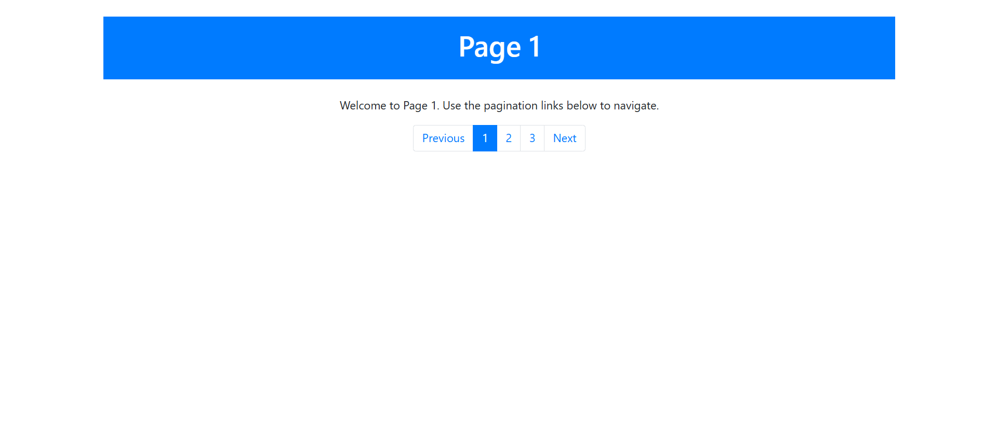

PAGE 2 HTML CODE

<!DOCTYPE html>
<html lang="en">
<head>
<meta charset="UTF-8">
<meta name="viewport" content="width=device-width, initial-scale=1.0">
<title>Page 2</title>
<!-- Bootstrap CSS -->
<link href="https://stackpath.bootstrapcdn.com/bootstrap/4.5.2/css/bootstrap.min.css" rel="stylesheet">
</head>
<body>
<div class="container mt-4">
<!-- Header with centered alignment and color class -->
<div class="text-center bg-success text-white p-3">
<h1>Page 2</h1>
</div>

<!-- Page content -->
<div class="text-center mt-4">
<p>Welcome to Page 2. Use the pagination links below to navigate.</p>
</div>

<!-- Pagination -->
<div class="d-flex justify-content-center">
<ul class="pagination">
<li class="page-item">
<a class="page-link" href="page1.html" target="_blank">Previous</a>
</li>
<li class="page-item">
<a class="page-link" href="page1.html" target="_blank">1</a>
</li>
<li class="page-item active">
<a class="page-link" href="page2.html" target="_blank">2</a>
</li>
<li class="page-item">
<a class="page-link" href="page3.html" target="_blank">3</a>
</li>
<li class="page-item">
<a class="page-link" href="page3.html" target="_blank">Next</a>
</li>
</ul>
</div>
</div>
<script src="https://code.jquery.com/jquery-3.5.1.min.js"></script>
<script src="https://cdn.jsdelivr.net/npm/@popperjs/core@2.5.4/dist/umd/popper.min.js"></script>
<script src="https://stackpath.bootstrapcdn.com/bootstrap/4.5.2/js/bootstrap.min.js"></script>
</body>
</html>

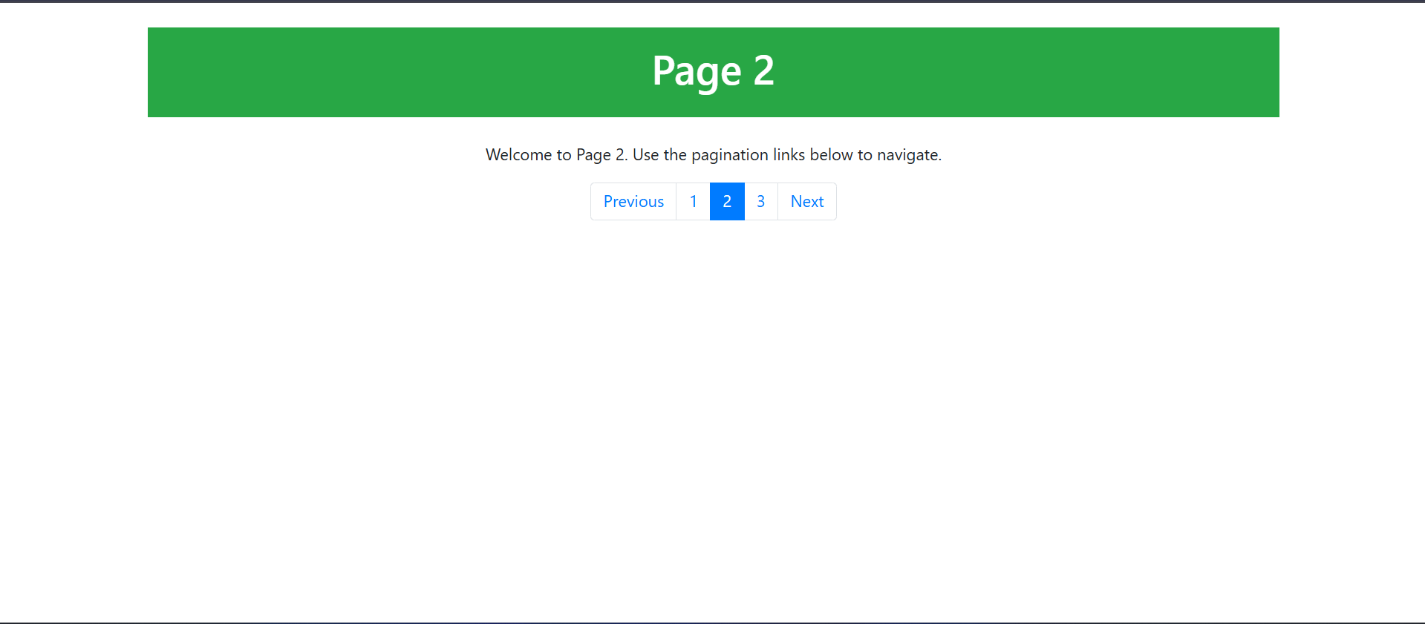

PAGE 3 HTML CODE :-

<!DOCTYPE html>
<html lang="en">
<head>
<meta charset="UTF-8">
<meta name="viewport" content="width=device-width, initial-scale=1.0">
<title>Page 3</title>
<!-- Bootstrap CSS -->
<link href="https://stackpath.bootstrapcdn.com/bootstrap/4.5.2/css/bootstrap.min.css" rel="stylesheet">
</head>
<body>
<div class="container mt-4">
<!-- Header with centered alignment and color class -->
<div class="text-center bg-warning text-dark p-3">
<h1>Page 3</h1>
</div>

<!-- Page content -->
<div class="text-center mt-4">
<p>Welcome to Page 3. Use the pagination links below to navigate.</p>
</div>

<!-- Pagination -->
<div class="d-flex justify-content-center">
<ul class="pagination">
<li class="page-item">
<a class="page-link" href="page2.html" target="_blank">Previous</a>
</li>
<li class="page-item">
<a class="page-link" href="page1.html" target="_blank">1</a>
</li>
<li class="page-item">
<a class="page-link" href="page2.html" target="_blank">2</a>
</li>
<li class="page-item active">
<a class="page-link" href="page3.html" target="_blank">3</a>
</li>
<li class="page-item">
<a class="page-link" href="page4.html" target="_blank">Next</a>
</li>
</ul>
</div>
</div>

<!-- Bootstrap JS -->
<script src="https://code.jquery.com/jquery-3.5.1.min.js"></script>
<script src="https://cdn.jsdelivr.net/npm/@popperjs/core@2.5.4/dist/umd/popper.min.js"></script>
<script src="https://stackpath.bootstrapcdn.com/bootstrap/4.5.2/js/bootstrap.min.js"></script>
</body>
</html>

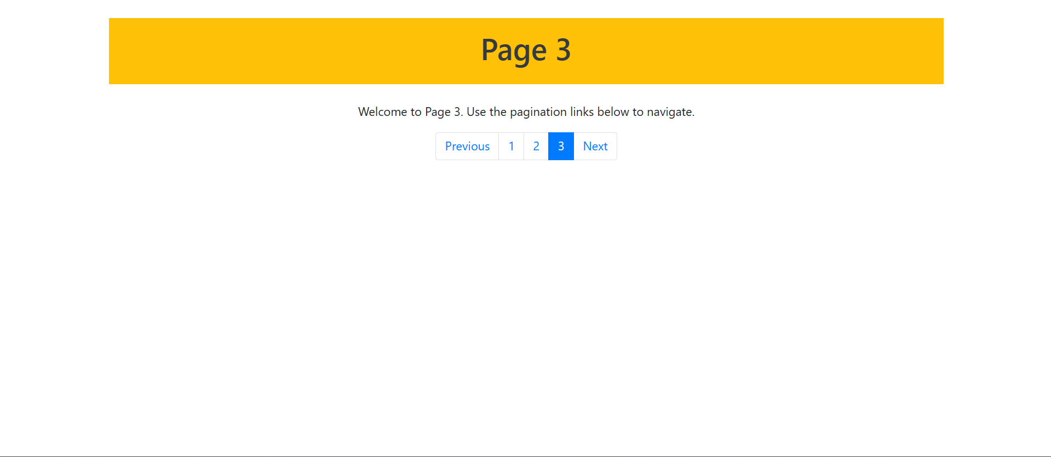

PAGE 4 HTML

<!DOCTYPE html>
<html lang="en">
<head>
<meta charset="UTF-8">
<meta name="viewport" content="width=device-width, initial-scale=1.0">
<title>Page 4</title>
<!-- Bootstrap CSS -->
<link href="https://stackpath.bootstrapcdn.com/bootstrap/4.5.2/css/bootstrap.min.css" rel="stylesheet">
</head>
<body>
<div class="container mt-4">
<!-- Header with centered alignment and color class -->
<div class="text-center bg-danger text-white p-3">
<h1>Page 4</h1>
</div>

<!-- Page content -->
<div class="text-center mt-4">
<p>Welcome to Page 4. Use the pagination links below to navigate.</p>
</div>

<!-- Pagination -->
<div class="d-flex justify-content-center">
<ul class="pagination">
<li class="page-item active">
<a class="page-link" href="page1.html" target="_blank">Previous</a>
</li>
<li class="page-item">
<a class="page-link" href="page1.html" target="_blank">1</a>
</li>
<li class="page-item">
<a class="page-link" href="page2.html" target="_blank">2</a>
</li>
<li class="page-item">
<a class="page-link" href="page3.html" target="_blank">3</a>
</li>
<li class="page-item active">
<a class="page-link" href="page4.html" target="_blank">4</a>
</li>
</ul>
</div>
</div>

<!-- Bootstrap JS -->
<script src="https://code.jquery.com/jquery-3.5.1.min.js"></script>
<script src="https://cdn.jsdelivr.net/npm/@popperjs/core@2.5.4/dist/umd/popper.min.js"></script>
<script src="https://stackpath.bootstrapcdn.com/bootstrap/4.5.2/js/bootstrap.min.js"></script>
</body>
</html>

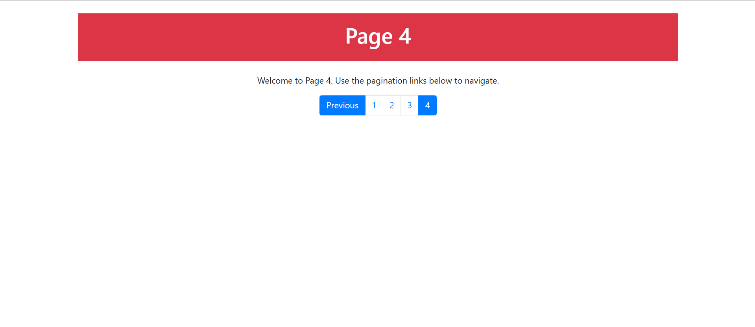

8. Design a tutorial webpage for HTML using the following Bootstrap components: jumbotron, navbar, nav tabs, nav pills, and pagination.

HTML CODE

<!DOCTYPE html>
<html lang="en">
<head>
<meta charset="UTF-8">
<meta name="viewport" content="width=device-width, initial-scale=1.0">
<title>HTML Tutorial</title>
<!-- Bootstrap CSS -->
<link href="https://stackpath.bootstrapcdn.com/bootstrap/4.5.2/css/bootstrap.min.css" rel="stylesheet">
<style>
.jumbotron {
background-color: #f8f9fa;
}
.tutorial-content {
margin-top: 30px;
}
</style>
</head>
<body>

<!-- Navbar -->
<nav class="navbar navbar-expand-lg navbar-light bg-light">
<a class="navbar-brand" href="#">HTML Tutorial</a>
<button class="navbar-toggler" type="button" data-toggle="collapse" data-target="#navbarNav" aria-controls="navbarNav" aria-expanded="false" aria-label="Toggle navigation">
<span class="navbar-toggler-icon"></span>
</button>
<div class="collapse navbar-collapse" id="navbarNav">
<ul class="navbar-nav ml-auto">
<li class="nav-item active">
<a class="nav-link" href="#">Home</a>
</li>
<li class="nav-item">
<a class="nav-link" href="#tutorial">Tutorial</a>
</li>
<li class="nav-item">
<a class="nav-link" href="#contact">Contact</a>
</li>
</ul>
</div>
</nav>

<!-- Jumbotron -->
<div class="jumbotron jumbotron-fluid">
<div class="container">
<h1 class="display-4">Welcome to HTML Tutorial</h1>
<p class="lead">Learn HTML with easy-to-understand examples and interactive lessons.</p>
</div>
</div>

<!-- Tutorial Content -->
<div class="container tutorial-content">
<!-- Nav Tabs -->
<ul class="nav nav-tabs" id="tutorialTab" role="tablist">
<li class="nav-item">
<a class="nav-link active" id="htmlBasics-tab" data-toggle="tab" href="#htmlBasics" role="tab" aria-controls="htmlBasics" aria-selected="true">HTML Basics</a>
</li>
<li class="nav-item">
<a class="nav-link" id="htmlElements-tab" data-toggle="tab" href="#htmlElements" role="tab" aria-controls="htmlElements" aria-selected="false">HTML Elements</a>
</li>
<li class="nav-item">
<a class="nav-link" id="htmlForms-tab" data-toggle="tab" href="#htmlForms" role="tab" aria-controls="htmlForms" aria-selected="false">HTML Forms</a>
</li>
<li class="nav-item">
<a class="nav-link" id="htmlAttributes-tab" data-toggle="tab" href="#htmlAttributes" role="tab" aria-controls="htmlAttributes" aria-selected="false">HTML Attributes</a>
</li>
</ul>

<!-- Tab Content -->
<div class="tab-content" id="tutorialTabContent">
<!-- HTML Basics -->
<div class="tab-pane fade show active" id="htmlBasics" role="tabpanel" aria-labelledby="htmlBasics-tab">
<h4>HTML Basics</h4>
<p>HTML stands for HyperText Markup Language. It is the standard language used to create web pages.</p>
<p>HTML uses various tags to define the structure of a webpage. Some basic tags include <code>&lt;html&gt;</code>, <code>&lt;head&gt;</code>, and <code>&lt;body&gt;</code>.</p>
</div>

<!-- HTML Elements -->
<div class="tab-pane fade" id="htmlElements" role="tabpanel" aria-labelledby="htmlElements-tab">
<h4>HTML Elements</h4>
<p>HTML elements are the building blocks of web pages. Elements can have attributes, content, and other elements inside them.</p>
<p>Common elements include <code>&lt;div&gt;</code>, <code>&lt;p&gt;</code>, <code>&lt;h1&gt;</code> to <code>&lt;h6&gt;</code>, and <code>&lt;a&gt;</code> for links.</p>
</div>

<!-- HTML Forms -->
<div class="tab-pane fade" id="htmlForms" role="tabpanel" aria-labelledby="htmlForms-tab">
<h4>HTML Forms</h4>
<p>HTML forms allow users to submit data to the server. A form is defined using the <code>&lt;form&gt;</code> tag, and inside it, you can use elements like <code>&lt;input&gt;</code>, <code>&lt;textarea&gt;</code>, and <code>&lt;button&gt;</code>.</p>
</div>

<!-- HTML Attributes -->
<div class="tab-pane fade" id="htmlAttributes" role="tabpanel" aria-labelledby="htmlAttributes-tab">
<h4>HTML Attributes</h4>
<p>HTML attributes provide additional information about elements. Common attributes include <code>id</code>, <code>class</code>, <code>href</code>, and <code>src</code>.</p>
</div>
</div>

<!-- Nav Pills (Section Navigation) -->
<ul class="nav nav-pills justify-content-center my-4">
<li class="nav-item">
<a class="nav-link active" id="htmlBasics-pill" data-toggle="pill" href="#htmlBasics">HTML Basics</a>
</li>
<li class="nav-item">
<a class="nav-link" id="htmlElements-pill" data-toggle="pill" href="#htmlElements">HTML Elements</a>
</li>
<li class="nav-item">
<a class="nav-link" id="htmlForms-pill" data-toggle="pill" href="#htmlForms">HTML Forms</a>
</li>
<li class="nav-item">
<a class="nav-link" id="htmlAttributes-pill" data-toggle="pill" href="#htmlAttributes">HTML Attributes</a>
</li>
</ul>

<!-- Pagination -->
<nav>
<ul class="pagination justify-content-center">
<li class="page-item disabled">
<a class="page-link" href="#" tabindex="-1" aria-disabled="true">Previous</a>
</li>
<li class="page-item active" aria-current="page">
<a class="page-link" href="#">1</a>
</li>
<li class="page-item">
<a class="page-link" href="#">2</a>
</li>
<li class="page-item">
<a class="page-link" href="#">3</a>
</li>
<li class="page-item">
<a class="page-link" href="#">Next</a>
</li>
</ul>
</nav>
</div>
<script src="https://code.jquery.com/jquery-3.5.1.slim.min.js"></script>
<script src="https://cdn.jsdelivr.net/npm/@popperjs/core@2.5.4/dist/umd/popper.min.js"></script>
<script src="https://stackpath.bootstrapcdn.com/bootstrap/4.5.2/js/bootstrap.min.js"></scrip>

</body>
</html>

OUTPUT

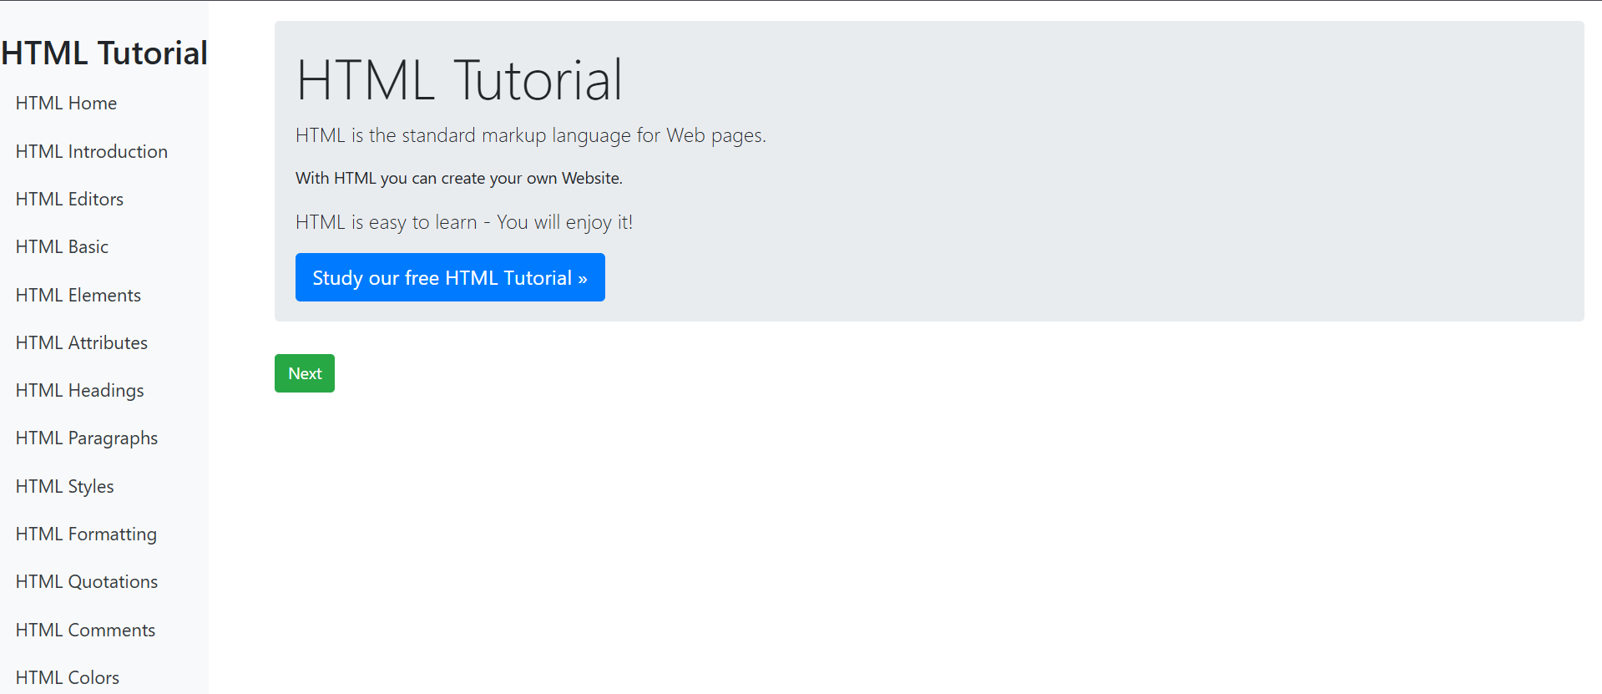

9. Design a New Year card gallery using Bootstrap cards. Each card should include a description, an image, and a link at the bottom, as shown below. You may add additional properties to enhance the appearance and create a visually appealing design.

HTML CODE

<!DOCTYPE html>
<html lang="en">
<head>
<meta charset="UTF-8">
<meta name="viewport" content="width=device-width, initial-scale=1.0">
<title>New Year Card Gallery</title>
<!-- Bootstrap CSS -->
<link href="https://stackpath.bootstrapcdn.com/bootstrap/4.5.2/css/bootstrap.min.css" rel="stylesheet">
<style>
.card {
border-radius: 15px;
overflow: hidden;
box-shadow: 0 4px 10px rgba(0, 0, 0, 0.1);
transition: transform 0.3s ease-in-out;
}

.card:hover {
transform: translateY(-10px);
box-shadow: 0 6px 20px rgba(0, 0, 0, 0.2);
}

.card img {
height: 200px;
object-fit: cover;
width: 100%;
}

.card-body {
background-color: #f9f9f9;
padding: 20px;
text-align: center;
}

.card-title {
font-size: 1.25rem;
font-weight: bold;
color: #333;
}

.card-text {
font-size: 1rem;
color: #666;
}

.btn {
background-color: #007bff;
color: #fff;
border-radius: 20px;
padding: 10px 20px;
text-transform: uppercase;
letter-spacing: 1px;
}

.btn:hover {
background-color: #0056b3;
color: #fff;
}

.gallery-container {
margin-top: 30px;
}
</style>
</head>
<body>

<div class="container gallery-container">
<h1 class="text-center mb-5">New Year Card Gallery</h1>

<div class="row">
<!-- Card 1 -->
<div class="col-md-4 mb-4">
<div class="card">
<img src="https://img.freepik.com/premium-vector/new-year-2025-typography-logo-design-happy-new-year-2025-logo-design_688395-830.jpg" alt="New Year 1">
<div class="card-body">
<h5 class="card-title">Happy New Year!</h5>
<p class="card-text">Wishing you a year full of happiness, health, and success. Let's make this year unforgettable!</p>
<a href="#" class="btn" target="_blank">See More</a>
</div>
</div>
</div>

<!-- Card 2 -->
<div class="col-md-4 mb-4">
<div class="card">
<img src="https://img.freepik.com/premium-vector/2025-happy-new-year-text-design_591998-1621.jpg" alt="New Year 2">
<div class="card-body">
<h5 class="card-title">Cheers to New Beginnings!</h5>
<p class="card-text">Embrace the joy and excitement of the new year. May your dreams come true!</p>
<a href="#" class="btn" target="_blank">See More</a>
</div>
</div>
</div>

<!-- Card 3 -->
<div class="col-md-4 mb-4">
<div class="card">
<img src="https://i.pinimg.com/736x/10/37/6c/10376ccf23c55087f02b777f3147eb8e.jpg" alt="New Year 3">
<div class="card-body">
<h5 class="card-title">New Year, New Adventures!</h5>
<p class="card-text">Get ready to explore new opportunities and take on exciting adventures this year!</p>
<a href="#" class="btn" target="_blank">See More</a>
</div>
</div>
</div>

<!-- Card 4 -->
<div class="col-md-4 mb-4">
<div class="card">
<img src="https://i.pinimg.com/736x/32/fe/69/32fe6923b742a4eb56ff8dfa2ef2f7b6.jpg" alt="New Year 4">
<div class="card-body">
<h5 class="card-title">Joyous Moments Ahead!</h5>
<p class="card-text">May this year bring peace, prosperity, and endless joy into your life.</p>
<a href="#" class="btn" target="_blank">See More</a>
</div>
</div>
</div>

<!-- Card 5 -->
<div class="col-md-4 mb-4">
<div class="card">
<img src="https://i.pinimg.com/736x/75/10/48/7510481a511f80a5cafdfd204880fb0a.jpg" alt="New Year 5">
<div class="card-body">
<h5 class="card-title">A Year of Happiness!</h5>
<p class="card-text">Let's welcome this new year with open arms and lots of love. May it be full of wonderful surprises!</p>
<a href="#" class="btn" target="_blank">See More</a>
</div>
</div>
</div>

<!-- Card 6 -->
<div class="col-md-4 mb-4">
<div class="card">
<img src="https://i.pinimg.com/736x/22/4a/64/224a6470d3eb6b0f0b268320ea8e9657.jpg" alt="New Year 6">
<div class="card-body">
<h5 class="card-title">New Year, New Hopes!</h5>
<p class="card-text">Let this be the year you shine the brightest. May your hopes and dreams lead the way!</p>
<a href="#" class="btn" target="_blank">See More</a>
</div>
</div>
</div>
</div>
</div>

<!-- Bootstrap JS and dependencies -->
<script src="https://code.jquery.com/jquery-3.5.1.slim.min.js"></script>
<script src="https://cdn.jsdelivr.net/npm/@popperjs/core@2.5.4/dist/umd/popper.min.js"></script>
<script src="https://stackpath.bootstrapcdn.com/bootstrap/4.5.2/js/bootstrap.min.js"></script>

</body>
</html>

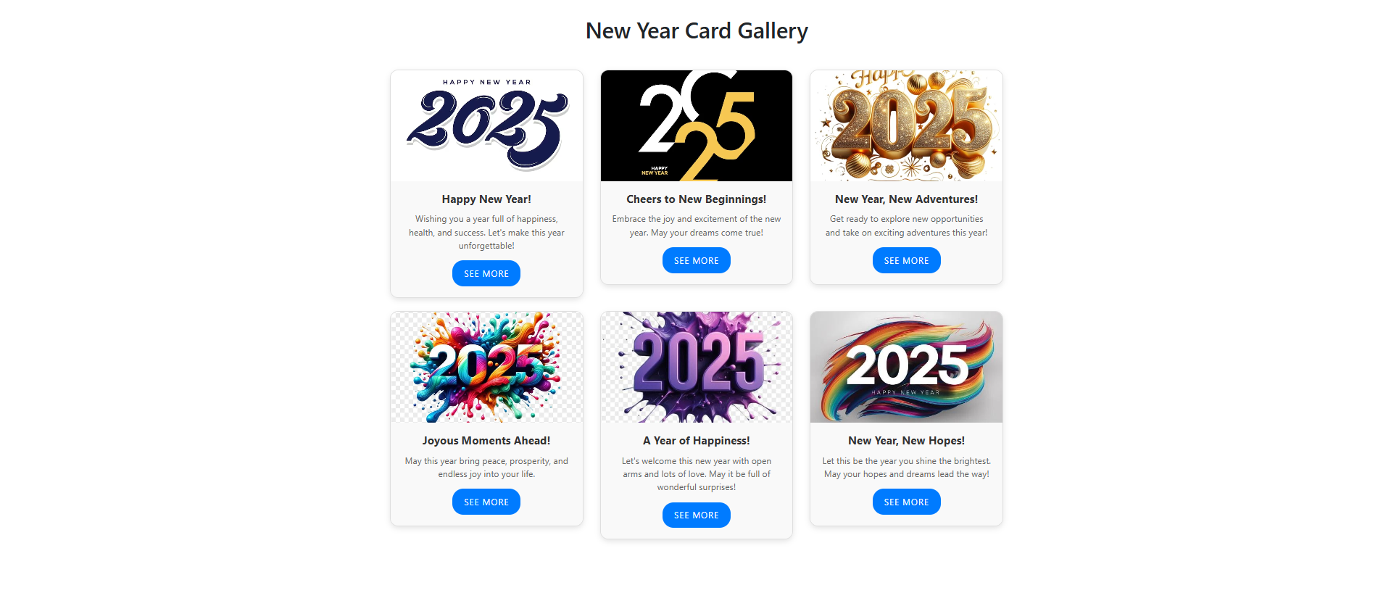

10. Design a slideshow featuring five historical monuments of India, including captions and descriptions for each, using a Bootstrap carousel.

HTML CODE

<!DOCTYPE html>
<html lang="en">
<head>
<meta charset="UTF-8">
<meta name="viewport" content="width=device-width, initial-scale=1.0">
<title>Historical Monuments of India</title>
<!-- Bootstrap CSS -->
<link href="https://stackpath.bootstrapcdn.com/bootstrap/4.5.2/css/bootstrap.min.css" rel="stylesheet">
<style>
.carousel-item img {
width: 100%;
height: 500px;
object-fit: cover;
}

.carousel-caption {
background-color: rgba(0, 0, 0, 0.5);
color: white;
}

.carousel-inner {
border-radius: 20px;
}

.carousel-control-prev-icon, .carousel-control-next-icon {
background-color: black;
}

.container {
margin-top: 40px;
}
</style>
</head>
<body>

<div class="container">
<h1 class="text-center mb-4">Historical Monuments of India</h1>

<div id="monumentsCarousel" class="carousel slide" data-ride="carousel">
<div class="carousel-inner">

<!-- Monument 1 - Taj Mahal -->
<div class="carousel-item active">
<img src="https://i.pinimg.com/1200x/44/04/f8/4404f8ea1193c2d49c0ffd39499eb7d0.jpg" class="d-block w-100" alt="Taj Mahal">
<div class="carousel-caption d-none d-md-block">
<h5>Taj Mahal</h5>
<p>A symbol of love, located in Agra, this magnificent white marble mausoleum was built by Emperor Shah Jahan in memory of his wife Mumtaz Mahal.</p>
</div>
</div>

<!-- Monument 2 - Qutub Minar -->
<div class="carousel-item">
<img src="https://media.istockphoto.com/id/1160975059/photo/qutub-minar-and-its-monuments-delhi.jpg?b=1&s=612x612&w=0&k=20&c=eWycq3gYobAJjiSL6qk_cMqIn-94RLbiV67T3Sv88fc=" class="d-block w-100" alt="Qutub Minar">
<div class="carousel-caption d-none d-md-block">
<h5>Qutub Minar</h5>
<p>Located in Delhi, this 73-meter tall minaret is a UNESCO World Heritage Site and an example of Indo-Islamic Afghan architecture.</p>
</div>
</div>

<!-- Monument 3 - Red Fort -->
<div class="carousel-item">
<img src="https://images.unsplash.com/photo-1547300848-441153a7bf02?fm=jpg&q=60&w=3000&ixlib=rb-4.0.3&ixid=M3wxMjA3fDB8MHxzZWFyY2h8NHx8cmVkJTIwZm9ydHxlbnwwfHwwfHx8MA%3D%3D" class="d-block w-100" alt="Red Fort">
<div class="carousel-caption d-none d-md-block">
<h5>Red Fort</h5>
<p>Built in the 17th century by Emperor Shah Jahan, the Red Fort in Delhi is a symbol of India's rich history and a UNESCO World Heritage Site.</p>
</div>
</div>

<!-- Monument 4 - Gateway of India -->
<div class="carousel-item">
<img src="https://t3.ftcdn.net/jpg/06/02/09/88/360_F_602098878_8WkD9zyRbG4giJkhCXVpMl5s3SA5GclD.jpg" class="d-block w-100" alt="Gateway of India">
<div class="carousel-caption d-none d-md-block">
<h5>Gateway of India</h5>
<p>Located in Mumbai, this grand archway was built to commemorate the visit of King George V and Queen Mary to India in 1911.</p>
</div>
</div>
<!-- Monument 5 - India Gate -->
<div class="carousel-item">
<img src="https://i.pinimg.com/1200x/0e/1a/de/0e1adecc437a71ee469fcda79c1edfd4.jpg" class="d-block w-100" alt="India Gate">
<div class="carousel-caption d-none d-md-block">
<h5>India Gate</h5>
<p>A war memorial in Delhi, the India Gate commemorates the soldiers who died during World War I. It is a national symbol of India.</p>
</div>
</div>
</div>
<!-- Carousel controls -->
<a class="carousel-control-prev" href="#monumentsCarousel" role="button" data-slide="prev">
<span class="carousel-control-prev-icon" aria-hidden="true"></span>
<span class="sr-only">Previous</span>
</a>
<a class="carousel-control-next" href="#monumentsCarousel" role="button" data-slide="next">
<span class="carousel-control-next-icon" aria-hidden="true"></span>
<span class="sr-only">Next</span>
</a>
</div>
</div>
<!-- Bootstrap JS and dependencies -->
<script src="https://code.jquery.com/jquery-3.5.1.slim.min.js"></script>
<script src="https://cdn.jsdelivr.net/npm/@popperjs/core@2.5.4/dist/umd/popper.min.js"></script>
<script src="https://stackpath.bootstrapcdn.com/bootstrap/4.5.2/js/bootstrap.min.js"></script>
</body>
</html>

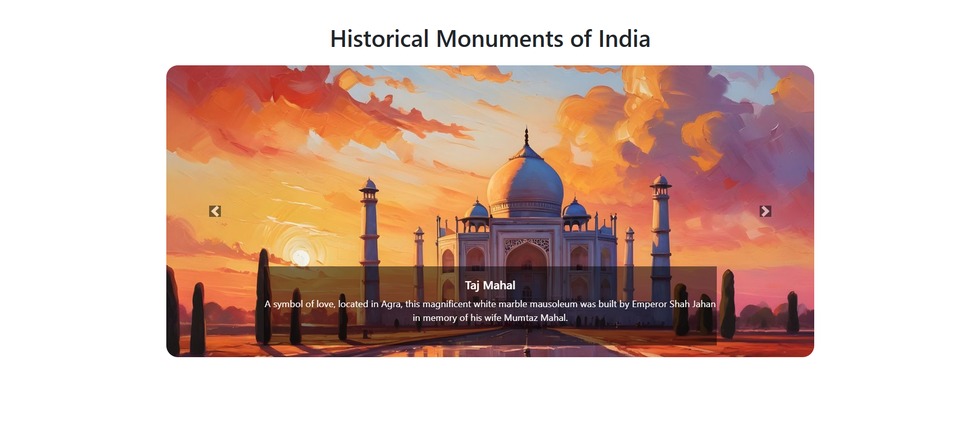

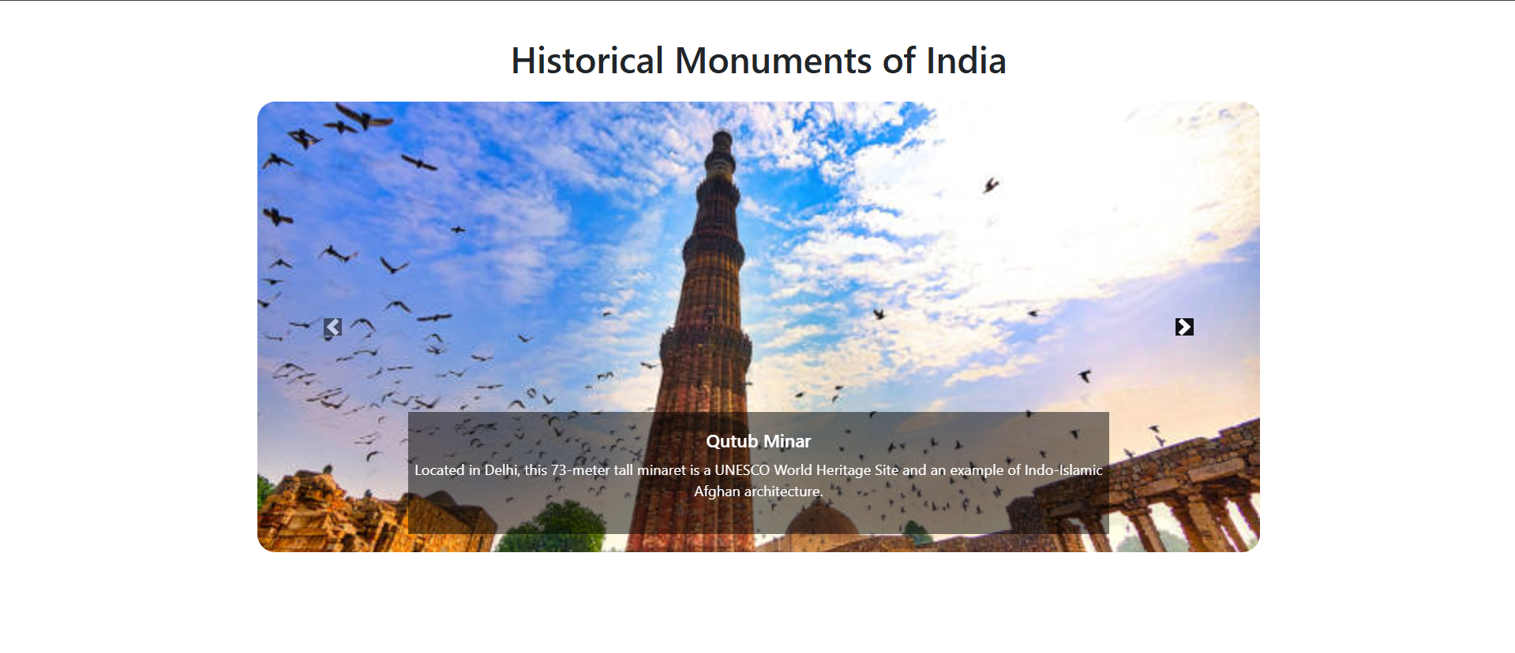

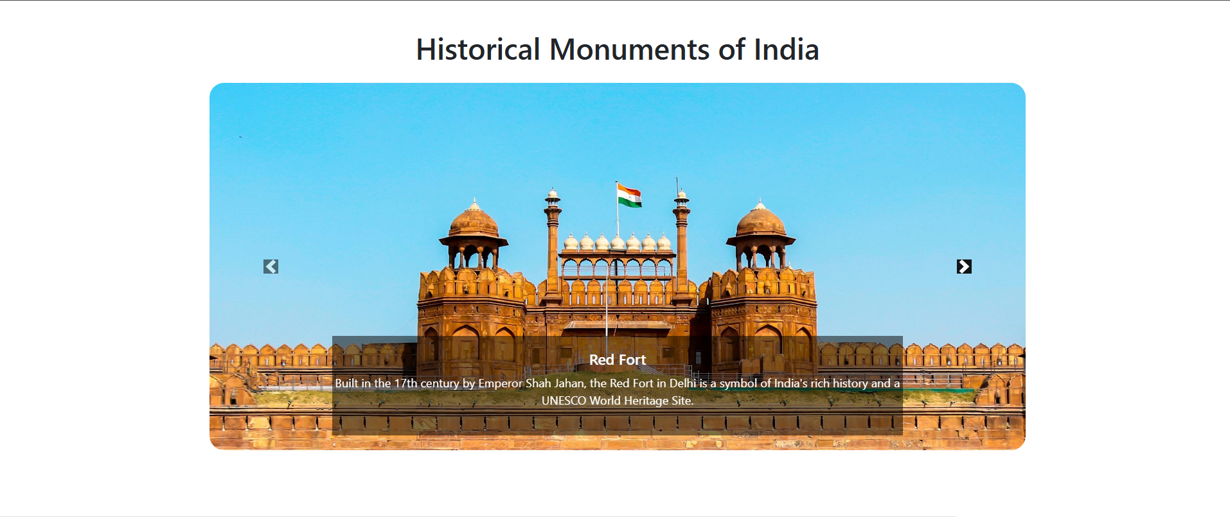
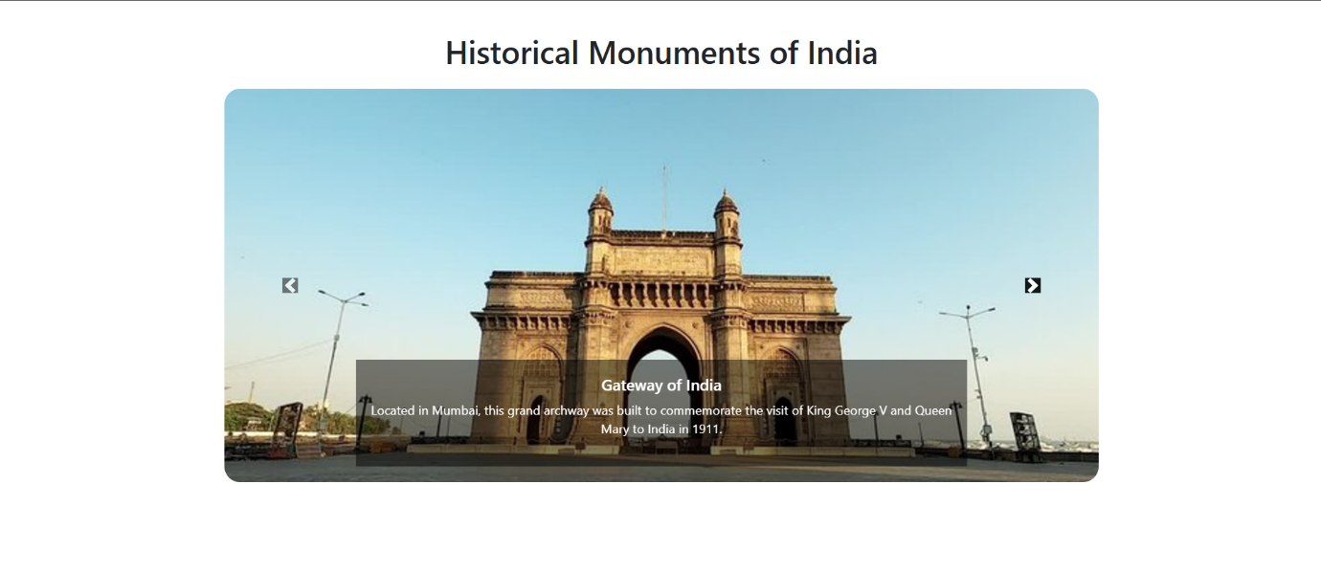
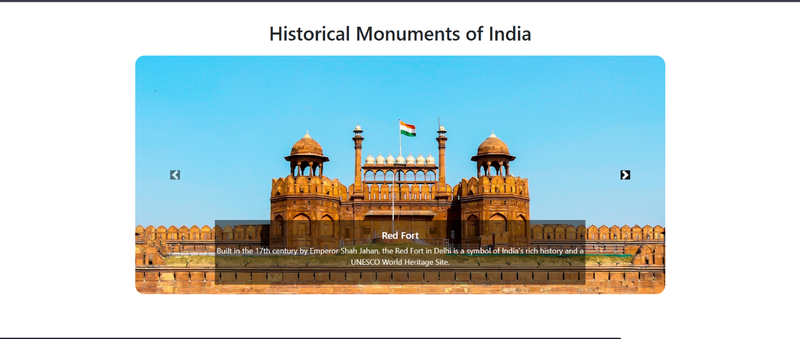

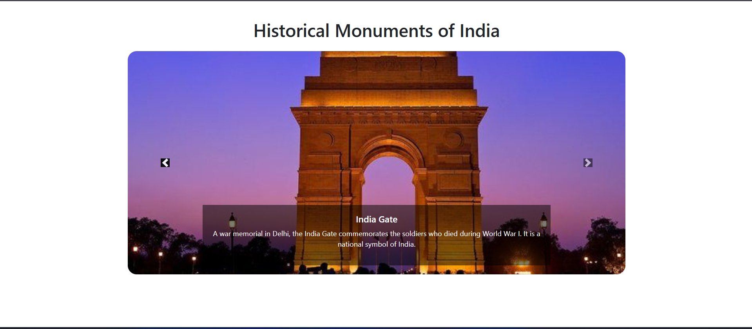

11. Design a stacked form with appropriate input fields to capture data, including fields for registration number, email, password, gender, and a submit button.

HTML CODE

<!DOCTYPE html>
<html lang="en">
<head>
<meta charset="UTF-8">
<meta name="viewport" content="width=device-width, initial-scale=1.0">
<title>Registration Form</title>
<!-- Bootstrap CSS -->
<link href="https://stackpath.bootstrapcdn.com/bootstrap/4.5.2/css/bootstrap.min.css" rel="stylesheet">
<style>
.form-container {
margin-top: 50px;
max-width: 500px;
margin-left: auto;
margin-right: auto;
}
</style>
</head>
<body>

<div class="container form-container">
<h2 class="text-center mb-4">User Registration</h2>
<form action="#" method="POST">
<!-- Registration Number -->
<div class="form-group">
<label for="regNumber">Registration Number</label>
<input type="text" class="form-control" id="regNumber" name="regNumber" placeholder="Enter Registration Number" required>
</div>

<!-- Email -->
<div class="form-group">
<label for="email">Email address</label>
<input type="email" class="form-control" id="email" name="email" placeholder="Enter email" required>
</div>

<!-- Password -->
<div class="form-group">
<label for="password">Password</label>
<input type="password" class="form-control" id="password" name="password" placeholder="Enter password" required>
</div>

<!-- Gender -->
<div class="form-group">
<label for="gender">Gender</label>
<select class="form-control" id="gender" name="gender" required>
<option value="">Select Gender</option>
<option value="male">Male</option>
<option value="female">Female</option>
<option value="other">Other</option>
</select>
</div>

<!-- Submit Button -->
<button type="submit" class="btn btn-primary btn-block">Submit</button>
</form>
</div>

<!-- Bootstrap JS and dependencies -->
<script src="https://code.jquery.com/jquery-3.5.1.slim.min.js"></script>
<script src="https://cdn.jsdelivr.net/npm/@popperjs/core@2.5.4/dist/umd/popper.min.js"></script>
<script src="https://stackpath.bootstrapcdn.com/bootstrap/4.5.2/js/bootstrap.min.js"></script>

</body>
</html>

